ESCOLA ________________________________________DATA:_____/_____/_____
PROF:______________________________________________TURMA:___________NOME:_______________________________________________________________
Tabuada da adição
2+ 0 =
2+ 1 =
2+ 2 =
2+ 3 =
2+ 4 =
2+ 5 =
2+ 6 =
2+ 7 =
2+ 8 =
2+ 9 =
4+ 0 =
4+ 1 =
4+ 2 =
4+ 3 =
4+ 4 =
4+ 5 =
4+ 6 =
4+ 7 =
4+ 8 =
4+ 9 =
1+ 0 =
1+ 1 =
1+ 2 =
1+ 3 =
1+ 4 =
1+ 5 =
1+ 6 =
1+ 7 =
1+ 8 =
1+ 9 =
3+ 0 =
3+ 1 =
3+ 2 =
3+ 3 =
3+ 4 =
3+ 5 =
3+ 6 =
3+ 7 =
3+ 8 =
3+ 9 =


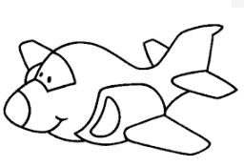


6+ 0 =
6+ 1 =
6+ 2 =
6+ 3 =
6+ 4 =
6+ 5 =
6+ 6 =
6+ 7 =
6+ 8 =
6+ 9 =
7+ 0 =
7+ 1 =
7+ 2 =
7+ 3 =
7+ 4 =
7+ 5 =
7+ 6 =
7+ 7 =
7+ 8 =
7+ 9 =
5+ 0 =
5+ 1 =
5+ 2 =
5+ 3 =
5+ 4 =
5+ 5 =
5+ 6 =
5+ 7 =
5+ 8 =
5+ 9 =




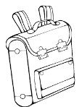
8+ 0 =
8+ 1 =
8+ 2 =
8+ 3 =
8+ 4 =
8+ 5 =
8+ 6 =
8+ 7 =
8+ 8 =
8+ 9 =
9+ 0 =
9+ 1 =
9+ 2 =
9+ 3 =
9+ 4 =
9+ 5 =
9+ 6 =
9+ 7 =
9+ 8 =
9+ 9 =


Vamos estudar juntos?

