ESCOLA ________________________________________DATA:_____/_____/_____
PROF:______________________________________________TURMA:___________NOME:_______________________________________________________________

Exercises
1.Complete a sequência:
a.one –_____________- three
b. _____________ – five - six
c.seven- eight - _____________
d.ten- _____________ - twelve
e.thirteen – _____________ – fifteen
f. _____________- seventeen – _____________
g.nineteen – _____________ – _____________

2.Calcule e escreva em inglês os resultados:
a.10 + 2 = ___________________
b.15 - 5 = ___________________
c.16 + 30 = ___________________
d.50 + 2 = ___________________
e.60+2+4= ___________________
f.5 x 8 = ___________________
g.10 x 2 = ___________________
h.10 – 2 = ___________________
i.30 + 7 = ___________________
j.42 – 7 = ___________________
k.55 – 6 = ___________________
l.27 + 8 + 25 = ________________
3.Assinale a opção correta:
a.One
( ) 1
( ) 2
( ) 13

b.Seventeen
( ) 16
( ) 26
( ) 17

c.Eighty
( ) 80
( ) 70
( ) 82

d.Ninety nine
( ) 90
( ) 99
( ) 93

e.Eleven
( ) 11
( ) 12
( ) 13

f.Fourteen
( ) 11
( ) 22
( ) 14

4.Escreva os números por extenso:
20 – Twenty
22 – _____________________
23 – _____________________
24 – _____________________
25 – _____________________
26 – _____________________
30 – Thirty
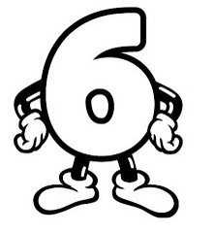
31 – _____________________
33 – _____________________
36 – _____________________
37 – _____________________
40 – Forty
45 – _____________________
47 – _____________________
49 – _____________________
50 – Fifty
55 – _____________________
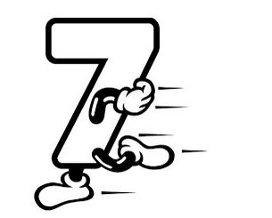
56 – _____________________
57 – _____________________
58 – _____________________
59 – _____________________
60 - Sixty
62 – _____________________
64 – _____________________
67 – _____________________

70 – Seventy
73 – _____________________
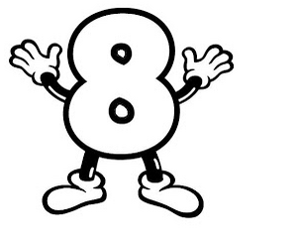
77 – _____________________
79 – _____________________
80 - Eighty
85 – _____________________
88 – _____________________
89 – _____________________
90 – Ninety
97 – _____________________
99 – _____________________
100 – _____________________

5.Faça os cálculos e escreva em inglês. Em seguida, com o resultado obtido, observe a legenda, e descubra quais são as cores que deverá utilizar para pintar o desenho.
a. zero + one = __________________
b. one + one = __________________
c. one + two = __________________
d.two + two = __________________
e.three + two= __________________
f.four + two = __________________
g.five + two = __________________
h.five + three = __________________
i.seven + two = __________________
j.five + five = __________________
k.nine + two = __________________
l. nine + three = __________________
m.nine + four = __________________
n.ten + four= __________________
o.ten + five = __________________
p.ten + six = __________________
q.ten + seven = __________________

Legenda:
One = yellow
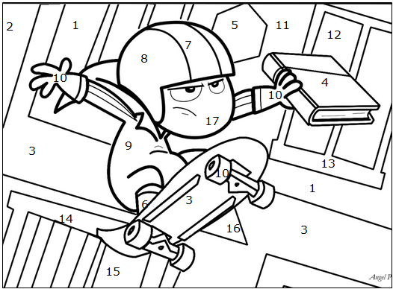
Two = green
Three =brown
Four = silver
Five =violet
Six = yellow
Seven = red
Eight = gray
Nine = blue
Ten = black
Eleven = gold
Twelve = orange
Thirteen= black
Fourteen= purple
Fifteen = navy blue
Sixteen= brown
Seventeen = beige

Ten Little Indians - Wizard (Songs)
One, little two, little three ,little Indians,
Four ,little five, little six, little Indians
Seven, little eight, little nine, little Indians, ten little Indians boys.
Ten , little nine, little Eight ,little Indians,
Seven ,little six, little Five, little Indians,
Four , little three, little two little Indians,
One little Indian boy.
One, two, three little Indians,
Four, five, six little Indians,
Seven, eight, nine little Indians,
Ten little Indians boys.
https://www.letras.mus.br/wizard-songs/1681542/traducao.html
6.Circule na letra da música todos os números mencionados, em seguida, pinte somente aqueles que aparecem na canção.
